1. Re-create the Customers And Orders tables, enhancing their definition with all primary and foreign keys constraints

Customer:

CREATE TABLE [dbo].[Customers](

[Customerid] [char](5) NOT NULL primary key,

[CompanyName] [varchar](40) NOT NULL,

[ContactName] [char](30) NULL,

[Address] [varchar](60) NULL,

[Town] [char](15) NULL,

[Phone] [char](24) NULL,

[Fax] [char](24) NULL

) ON [PRIMARY]

GO

SET ANSI_PADDING OFF

GO

ORDER:

CREATE TABLE [dbo].[Orders](

[OrderId] [int] NOT NULL CONSTRAINT PK_OrderId primary key,

[customerId] [char](5) NOT NULL Constraint FK_CustomerID Foreign key(customerId) References dbo.Customers(CustomerId),

[Orderdate] [datetime] NULL,

[Shippeddate] [datetime] NULL,

[Freight] [money] NULL,

[Shipname] [varchar](40) NULL,

[Shipaddres] [varchar](60) NULL,

[Quantity] [int] NULL

) ON [PRIMARY]

GO

SET ANSI_PADDING OFF

GO

ALTER TABLE [dbo].[Orders] ADD CONSTRAINT [Df_OrderDate] DEFAULT (getdate()) FOR [Orderdate]

GO

2. Using the ALTER TABLE statement, create an integrity constraint that limits the possible values of the quantity column in the Orders table to values between 1 and 30

IF EXISTS(SELECT 1 FROM sys.columns WHERE name = 'OrderId')

BEGIN

Alter Table dbo.[Orders] DROP CONSTRAINT PK_OrderId

Alter Table dbo.[Orders] Drop column OrderId

END

Alter Table dbo.[Orders]

Add OrderId INT NOT NULL Identity(1,1) CONSTRAINT PK_OrderId Primary Key

3. With the help of the corresponding system procedures and the Transact - SQL statements CREATE DEFAULT and CREATE RULE, create the alias data type “Western Countries”. The possible values for the new data type are CA(for California), WA( for Washington), OR( for Oregon), and NM( for New Mexico). The default value is CA. Finally, create a table called Regions with the columns City and Country using the new data type for the later.

4. Display all integrity constraints for the Orders table.

Select * fROM INFORMATION_SCHEMA.TABLE_CONSTRAINTS Where TABLE_NAME = 'Orders'

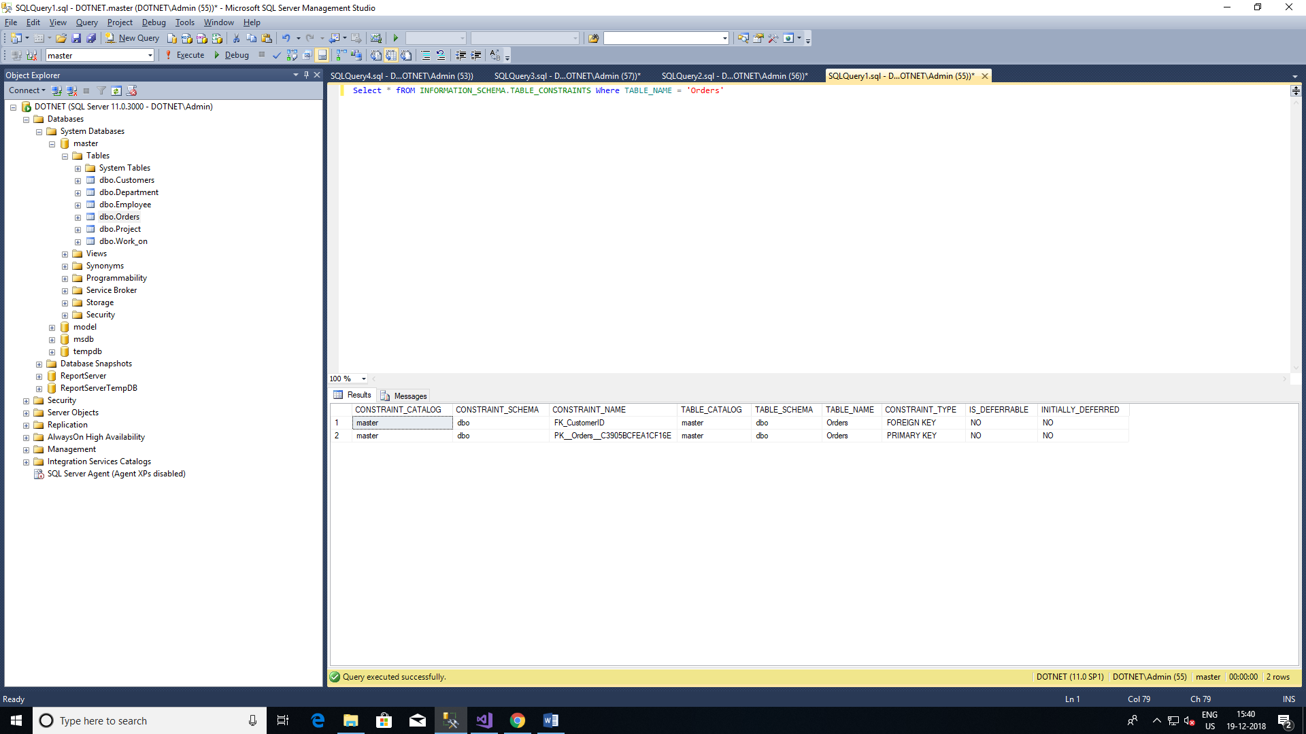

5. Delete the primary key of the Customers table. Why isn’t that working?

Because Of Foreign Key relationship between 2 table

Select * fROM dbo.Customers

Select * fROM dbo.Orders

Insert into dbo.Orders

values ( 10, getdate(), getdate(), 100.0, 'Windstar', 'Ocean' ,1)

Insert INTO Customers

Values(10,'CTS','RamaSubasree.M.S','XYZ','Banglore','9874563210','asdasd')

Delete Customers Where Customerid = 10

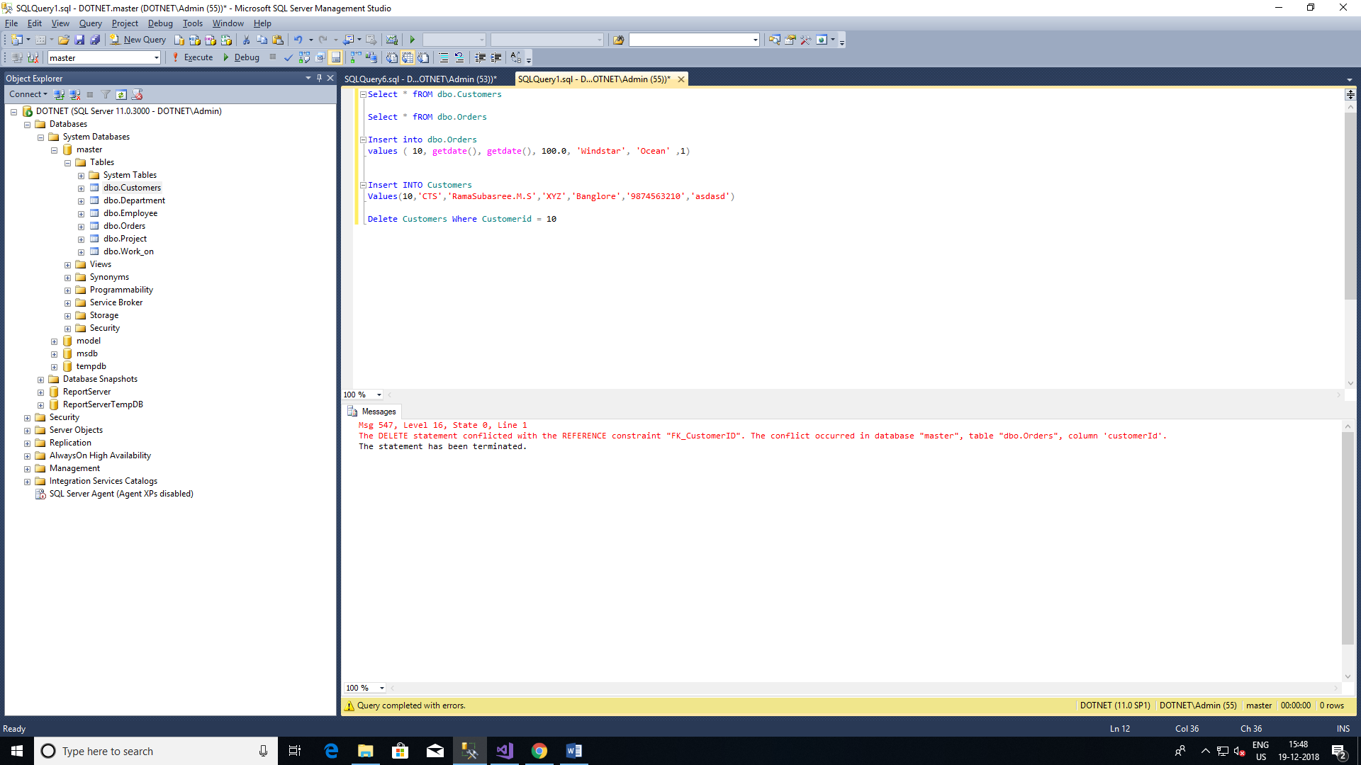

6. Delete the integrity constraint defined in Step-2

7. Write a function that will return the age of the person given his or her date of birth.

CREATE Function FN_GetAge(@DOB DATE)

RETURNS INT

BEGIN

DECLARE @Age INT

SET @Age = (SELECT DATEDIFF(yy,@DOB,getdate()))

RETURN @Age

END

declare @age int

SET @age = dbo.FN_GetAge ('11-04-1994')

select @age

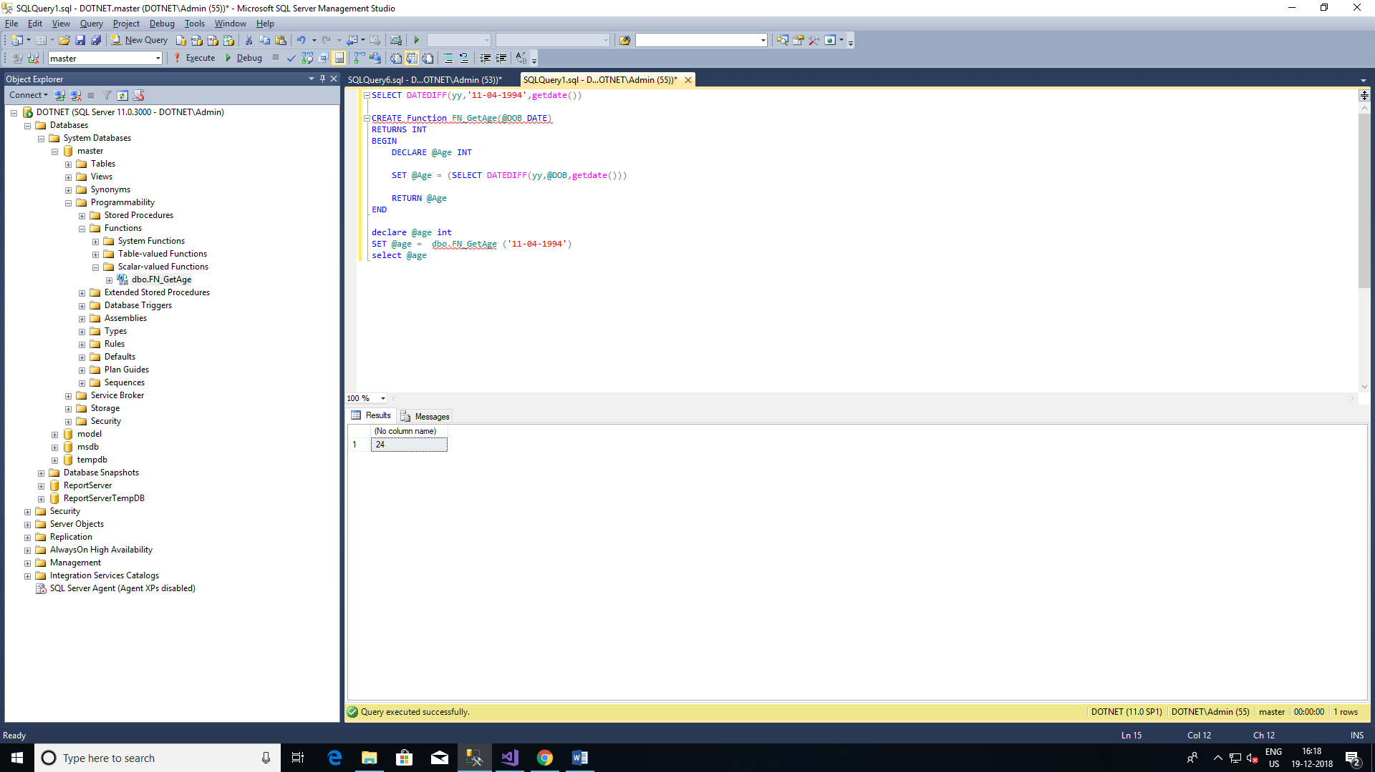

8.Write a procedure that accepts name and data of birth of the student and inserts the data in the student table with the date computed. The SID should be largest sid in the table +1.

Create table Student

(

StudentID INT Primary key,

Name Varchar(100),

DateofBirth Date,

Createddate DateTime

)

CREATE Procedure AddStudentDetails

@Name VarChar(100),

@DOB Date

As

BEGIN

DECLARE @StudentID INT = ISNULL((select Max(StudentID) from Student),0) + 1

Insert INTO Student

Select @StudentID,@Name,@DOB,GETDATE()

END

EXec AddStudentDetails 'Suba','1994-11-04'

select * from Student

